Form 1000 Instructions

- This form must be submitted every quarter. We do this as part of the Anti-Pyramid laws in the United States, in order to prove that we are moving products to other consumers and not just ourselves.
- If you have customers buying from you through your websites, then the form 1000 will be filled out for you by corporate.
- You need 2 separate sales in the system totaling at least $200 in retail pricing. These can be to the same customer at different times.
- First, we will go over how to create a Sales Receipt manually. This is only necessary if you have no online orders.

- At the top of UnFranchise.com, select Business, then go to My Customers, then go down to Sales Receipt Entry.

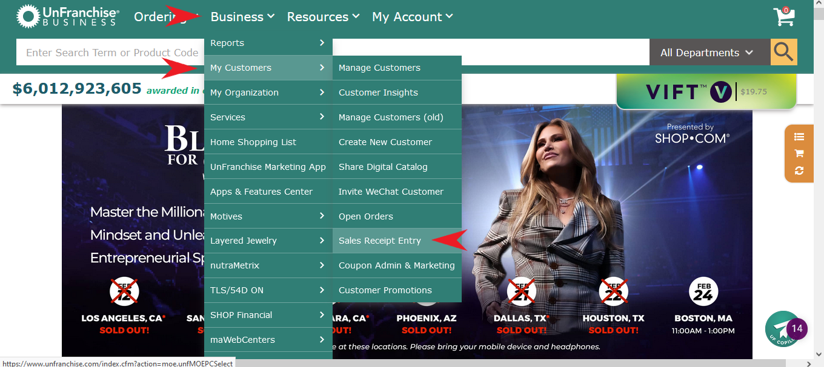

- This will give you a list of all your Preferred Customers. Find the customer you are looking for and click on their PC ID. This will show you their information. If this is correct, hit Continue.

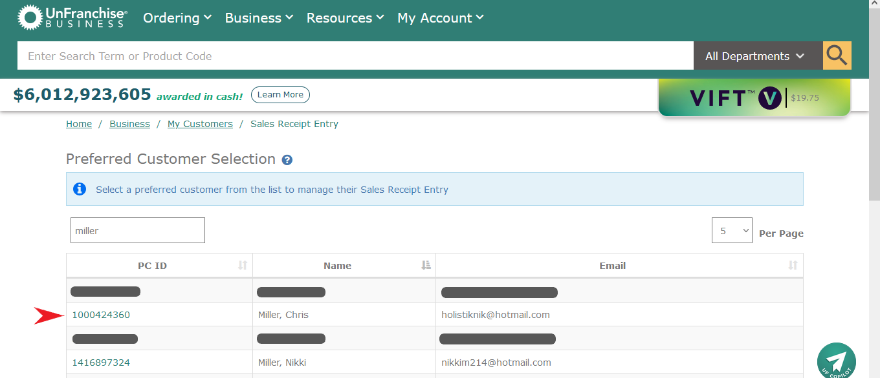

- At the top of the page is your Product Inventory Selection. This is a list of all the products in your inventory according to your order records through Market America. Select a product and Quantity until you have completed the order, then press Continue. Remember- you need at least 2 receipts with an overall total of at least $200 in retail.
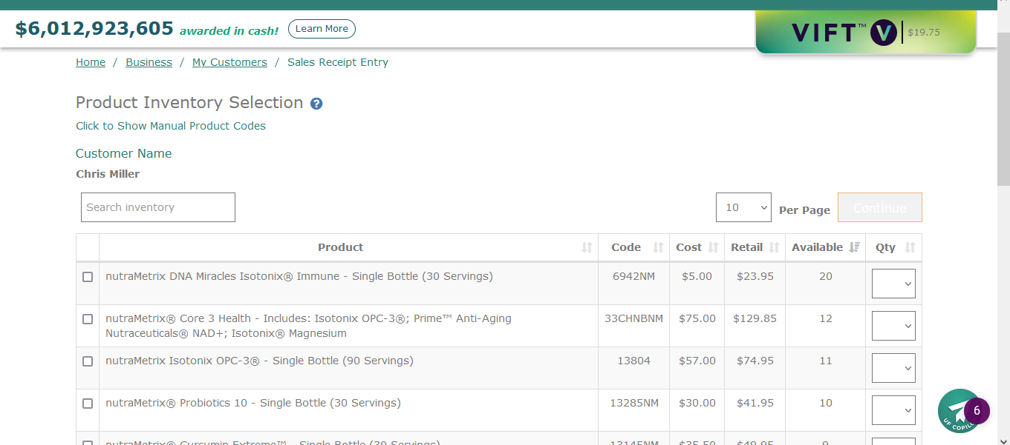

- This takes you to a Final Preview where you can review your Customer’s information, and a summary of the products in the order. Make sure to update the Order Date (near the bottom left corner) if this is being done on a different day. Press Continue and you are all set. Repeat as necessary.
- Next, go back to Unfranchise.com, then My Account, then Online Forms, then Form 1000.

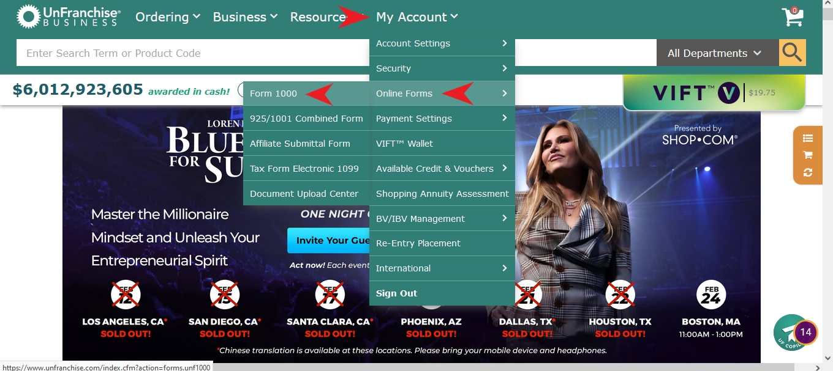

- Once you are at the form, you are looking at the Blue Circle. If it says Requirement Met in green, then you are all set! If not, we will scroll down the page. Also, if you need extra help at any time, you can click on Form 1000 Instructions (at the Red Arrow) to expand them and see more.
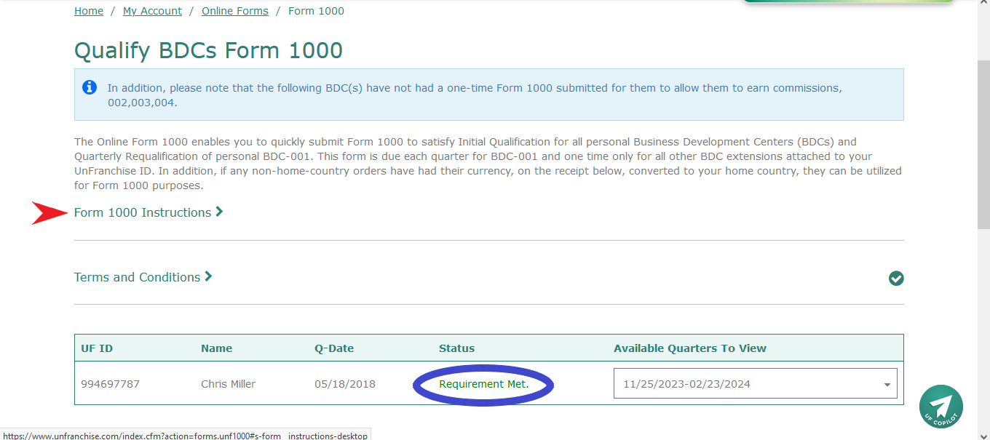

- We will scroll down to Assign Orders. Click on View Individual Orders if that is not already expanded. From there, click on any orders you have entered (totaling AT LEAST $200). When you’ve selected enough of them, go up to the Red Arrow and select your 001 BDC. Check the box that you agree to the Terms and Conditions, and Assign Selected should light up. Click that and you’re all done! You should then be able to scroll back up to the top of the form and see the green words for Requirement Met. Yay!
